PT Activity 2.5.3: Troubleshooting PPP Configuration (Solution)

Topology Diagram
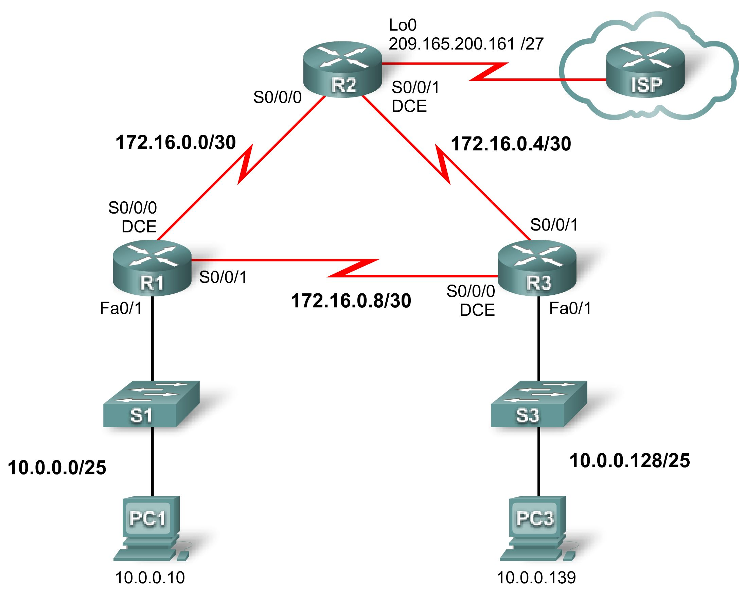

Addressing Table
Device | Interface | IP Address | Subnet Mask | Default Gateway
R1 | Fa0/1 | 10.0.0.1 | 255.255.255.128 | N/A
R1 | S0/0/0 | 172.16.0.1 | 255.255.255.252 | N/A
R1 | S0/0/1 | 172.16.0.9 | 255.255.255.252 | N/A
R2 | Lo0 | 209.165.200.161 | 255.255.255.224 | N/A
R2 | S0/0/0 | 172.16.0.2 | 255.255.255.252 | N/A
R2 | S0/0/1 | 172.16.0.5 | 255.255.255.252 | N/A
R3 | Fa0/1 | 10.0.0.129 | 255.255.255.128 | N/A
R3 | S0/0/0 | 172.16.0.10 | 255.255.255.252 | N/A
R3 | S0/0/1 | 172.16.0.6 | 255.255.255.252 | N/A
PC1 | NIC | 10.0.0.10 | 255.255.255.128 | 10.0.0.1
PC3 | NIC | 10.0.0.139 | 255.255.255.128 | 10.0.0.129

Learning Objectives
- Find and correct network errors.
- Document the corrected network.

Scenario
The routers at your company were configured by an inexperienced network engineer. Several errors in the configuration have resulted in connectivity issues. Your boss has asked you to troubleshoot and correct the configuration errors and document your work. Using your knowledge of PPP and standard testing methods, find and correct the errors. Make sure that all of the serial links use PPP CHAP authentication, and that all of the networks are reachable.
Task 1: Find and Correct Network Errors
- Use 64000 for all clock rates.
- Use cisco for all CHAP passwords.
Task 2: Document the Corrected Network
[Instructor Note: The following scripts show the correct configuration for each of the three routers.}
R1

R1#show run

!<output omitted>
!
hostname R1
!
!
enable secret cisco
!
!
no ip domain lookup
!
username R3 password 0 cisco This command is missing.
username R2 password 0 cisco
!
!
interface FastEthernet0/1 This address configuration is incorrectly
ip address 10.0.0.1 255.255.255.128 applied to interface Fa0/0.
no shutdown
!
interface Serial0/0/0
ip address 172.16.0.1 255.255.255.252 The subnet mask is incorrectly listed as 255.255.255.248.
encapsulation ppp The ppp commands are missing.
clockrate 64000
ppp authentication chap
no shutdown
!
interface Serial0/0/1
ip address 172.16.0.9 255.255.255.252
encapsulation ppp
ppp authentication chap Interface has pap for ppp authentication.
no shutdown
!
!
router ospf 1
network 10.0.0.0 0.0.0.127 area 0
network 172.16.0.0 0.0.0.3 area 0 This network is incorrectly advertised as
network 172.16.0.4 0.0.0.3 area 0.
network 172.16.0.8 0.0.0.3 area 0
!
!
banner motd ^CCUnauthorized access strictly prohibited and prosecuted to the full extent of the law^C
!
line con 0
exec-timeout 0 0
password cisco
logging synchronous
login
line aux 0
line vty 0 4
password cisco
login
!
end

R2

R2#show run

!<output omitted>
!
hostname R2
!
!
enable secret cisco
!
!
no ip domain lookup
!
username R1 password 0 cisco This command uses R11 instead of R1.
username R3 password 0 cisco This command uses class instead of cisco.
!
!
!
interface Loopback0 This address configuration is used on
ip address 209.165.200.161 255.255.255.224 Fa 0/1 instead of using Loopback0.
!
!
interface Serial0/0/0
ip address 172.16.0.2 255.255.255.252
encapsulation ppp
ppp authentication chap
no shutdown
!
interface Serial0/0/1 The ppp commands are missing.
ip address 172.16.0.5 255.255.255.252
encapsulation ppp
clockrate 64000 The clockrate 64000 is missing.
ppp authentication chap .
no shutdown
!
!
router ospf 1
network 172.16.0.0 0.0.0.3 area 0
network 172.16.0.4 0.0.0.3 area 0
network 209.165.200.160 0.0.0.31 area 0 Incorrect network 209.165.200.128 0.0.0.31 area 0 is listed.
!
!
banner motd ^CCUnauthorized access strictly prohibited and prosecuted to the full extent of the law^C
!
line con 0
exec-timeout 0 0
password cisco
logging synchronous
login
line aux 0
line vty 0 4
password cisco
login
!
end

R3

R3#show run
!<output omitted>
!
hostname R3
!
!
enable secret cisco
!
!
no ip domain lookup
!
username R1 password 0 cisco
username R2 password 0 cisco The username is incorrectly listed as R3 and the password is also incorrectly listed as ciscco.
!
!
interface FastEthernet0/1
ip address 10.0.0.129 255.255.255.128 The subnet mask 255.255.255.0 is incorrect.
no shutdown
!
interface Serial0/0/0 The ppp commands are missing.
ip address 172.16.0.10 255.255.255.252
encapsulation ppp
clockrate 64000
ppp authentication chap
no shutdown
!
interface Serial0/0/1 Interface is not configured.
ip address 172.16.0.6 255.255.255.252
encapsulation ppp
ppp authentication chap
no shutdown
!
router ospf 1
network 10.0.0.128 0.0.0.127 area 0
network 172.16.0.4 0.0.0.3 area 0 Incorrect networks 192.16.0.4 0.0.0.3 area 0 and
network 172.16.0.8 0.0.0.3 area 0 192.16.0.8 0.0.0.3 area 0 are configured.
!
!
banner motd ^CCUnauthorized access strictly prohibited and prosecuted to the full extent of the law^C
!
line con 0
exec-timeout 0 0
password cisco
logging synchronous
login
line aux 0
line vty 0 4
password cisco
login
!
end

